**GILBERDYKE HEALTH CENTRE**

**NEWSLETTER**



**July 2024**

**Summer Bank Holiday**

**The surgery will close for summer bank holiday at 6pm on Friday 23 August 2024 and reopen at 8am on Tuesday 27 August 2024.**

FOR URGENT **MEDICAL ADVICE** PHONE **111**

FOR **MEDICAL EMERGENCIES** PHONE **999**

**Retirement**

This month marks the retirement of one of our longest serving members of staff.

Sue Dykes our practice secretary is retiring after over 34 years at GHC.

We all wish Sue a long and healthy retirement.

**Dispensary**

The Dispensary team would like to thank patients for their understanding over the last few months. Deliveries and high demand for items have sometimes meant delays beyond their control. Thank you for your patience.

**Registrars**

The practice is pleased to welcome an additional Registrar this August. Dr Gent will join Dr Durrani and Dr Obi to provide care to our patients during their final months of training, supported by our GP’s. Their training is crucial in maintaining high standards for recruitment to general practice.

**Flu Clinics**

Flu clinic dates will be released as soon as we receive delivery notification of the vaccines at the beginning of October. Please look out for the dates on both our practice website and Facebook page. Messages will be sent to all those eligible, which includes all patients aged 65 and over and those under 65 in a clinical at risk group, as defined by the department of health.



**Prescription exemption certificates and pre-paid certificates**

Lots of patients have exemption and pre-paid certificates for their prescriptions. Please can we remind everyone to ensure these are up to date and haven’t run out. We have seen an increasing number of patients that have received fines due to the certificates expiring. It is the patient’s responsibility to renew these.

**Goole urgent treatment centre (UTC)**

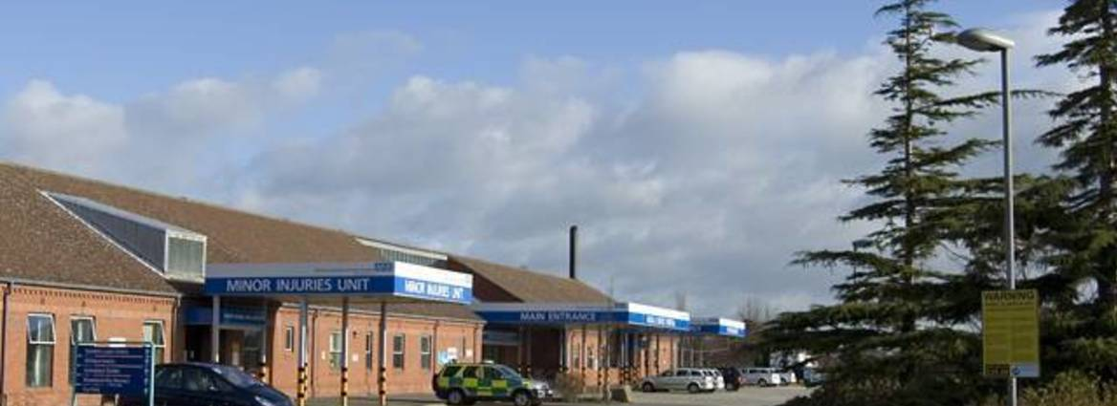

The practice does not offer a minor injuries clinic, but the Goole UTC is open 7 days a week, 365 days a year from 7am to 8pm. The service is located at Goole Hospital.

The UTC can help with:

* broken bones and sprains
* injuries, cuts, and bruises
* minor burns and scalds
* coughs, colds, and breathing problems
* sore throats and earache
* vomiting and diarrhoea
* skin infections and rashes
* high temperature (fever) in children and adults
* mental health problems
* minor eye complaints

**Over the counter medications**

Non-prescription or over-the-counter medication does not need a GP signature or authorisation for a school, nursery, or childminder to give it. We have had several requests for prescriptions as the above won’t administer without. The framework states that written permission from a parent is all that is required. For more guidance, please follow the link.

<https://www.bma.org.uk/advice-and-support/gp-practices/managing-workload/prescribing-over-the-counter-medicines-in-nurseries-and-schools>

**If you have any queries regarding the practice, please call us on**

**01430 440225**